EACH WEEK, you will need to earn a total of 50 POINTS! These can be added up any way, however you CANNOT repeat tasks! You can choose whichever activities you would like. This allows each of you to work on things that are interest to you and that you have the resources to complete.

The goal is that you are experiencing a variety of tasks related to the kitchen, food and baking in particular; so, try new things! Please read each box's directions CAREFULLY, and pay attention to how to submit correctly in order to earn your points. HAVE FUN!!!! - I’m excited to hear your feedback & learning along the way!☺

The best way to hand in your weeks’ worth of learning will be to fill in this chart with all of your information and then email to me at jpinnell@sd79.bc.ca. You can insert photos of your leaning, even photos of worksheets in the chart. If you choose to send worksheets and written work as a separate document please make a note on your weekly chart.

I will give you a blank page with the chart already set up so you just have to put in the work that you did for the week with the dates, save, name the document with your name in it and then email it to me.

EXAMPLE: Mrs. Pinnell’s choice board April 6-10
5 pts | 10 pts | 15 pts | 20 pts | 30 pts | 40 pts
Food Safety | Kitchen Equipment | Revive an old cookie sheet | Candy Unwrapped
Here are my quiz results  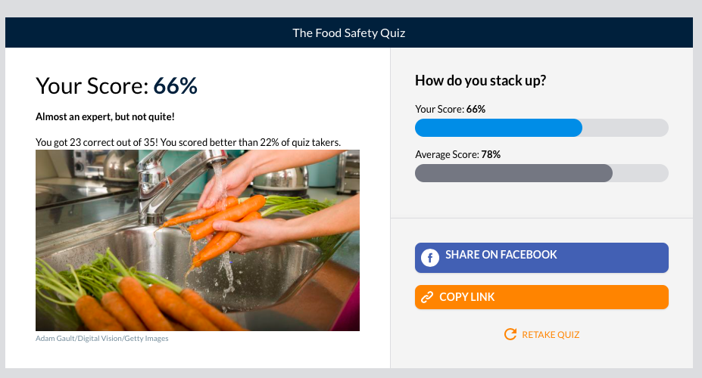 | 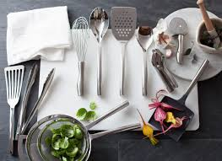  We are missing a liquid measuring cup | 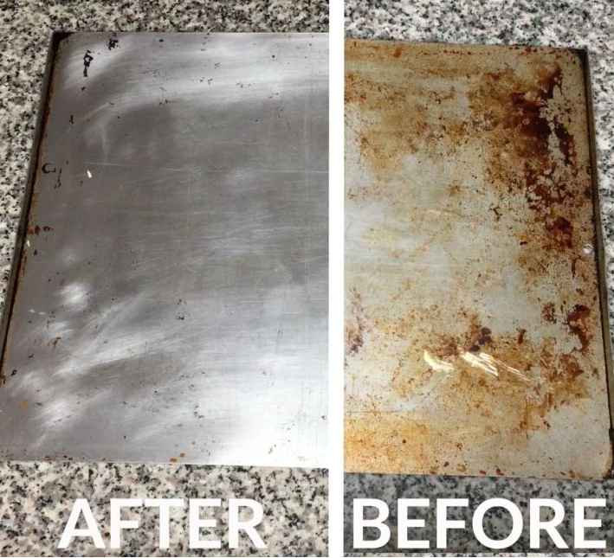 | I am sending my question sheet in an email to you.

