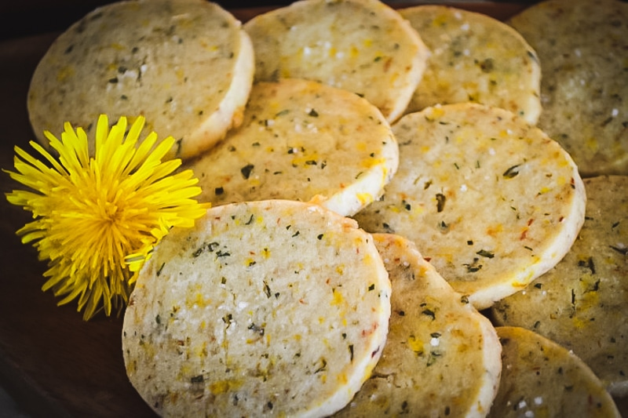 | 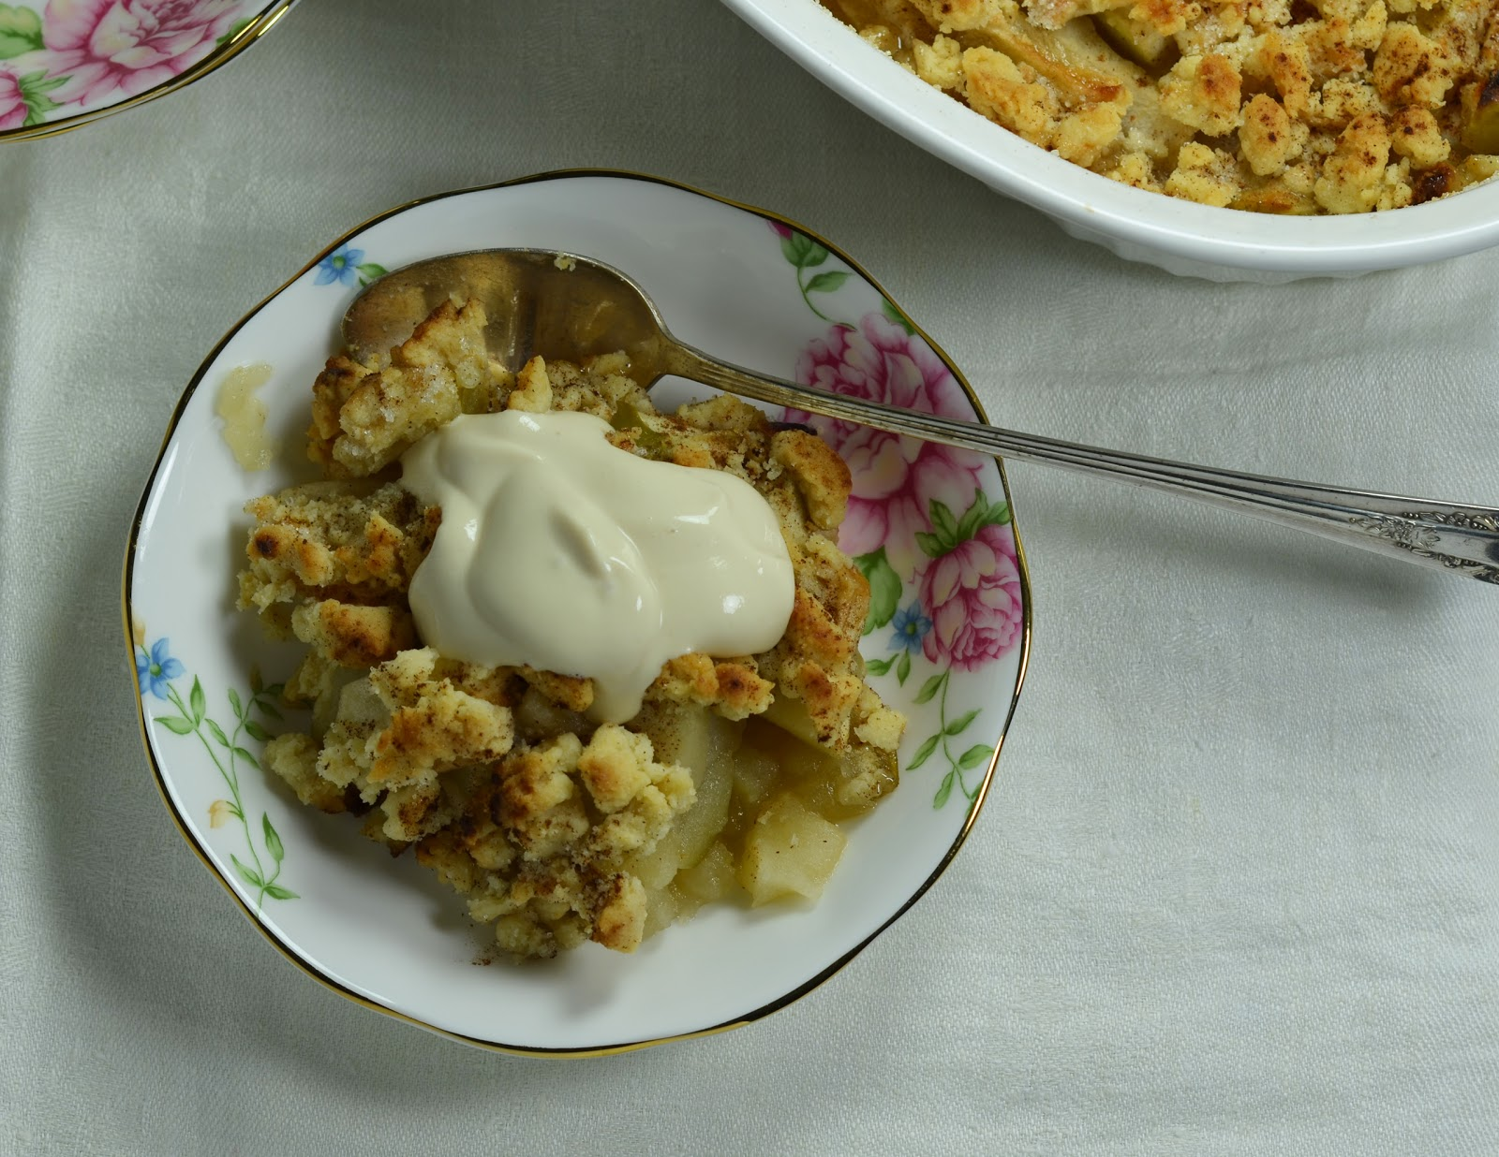 | 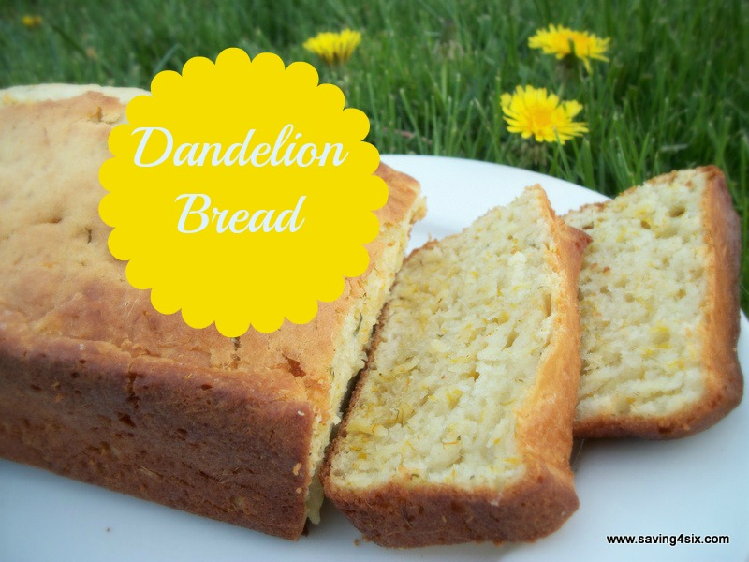 | 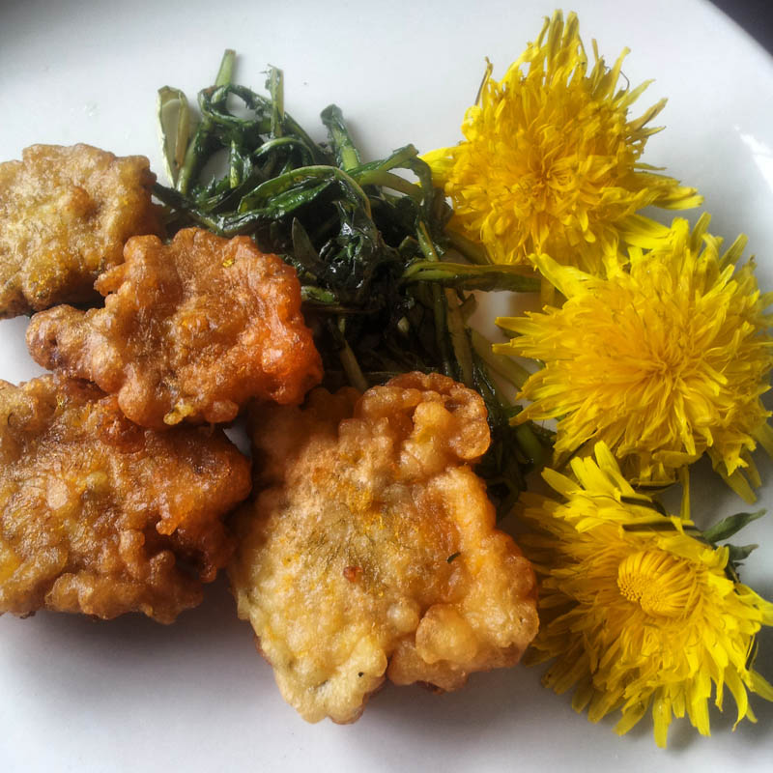

Preserving Medicinal Plant Knowledge - Traditional wisdom worth saving
https://www.alive.com/health/preserving-medicinal-plant-knowledge/

For thousands of years, plants have played a significant role in the lives of First Nations people. Trees were carved into canoes, flowers became natural dyes for clothing, and plants of all types were gathered for medicine.

One study counted nearly 550 plants with medicinal properties that were used by First Nations in the Canadian boreal forest. These plants treated nearly 30 different ailments, including fevers, colds, and diabetes.

“The foods we eat are medicine and healing,” says Coast Salish plant educator Cease Wyss. Her traditional name is T’uy’tanat, which translates to “medicine woman” in the Skwxwú7mesh (Squamish) language. Wyss has been teaching people about traditional uses of plants for more than 25 years. “[I’m] helping people to become educated, to be stewards of the land,” she explains.

Indigenous plant wisdom has been carefully discovered over thousands of years and passed down from one generation to the next through oral tradition. In today’s world, people are relying less on these teachings to survive. As First Nations elders pass away from old age, so do these teachings.

One way to preserve plant wisdom is to use traditional knowledge to gather and use medicinal plants. Wyss believes anybody can implement her traditional teachings, as long as they have the right motive. “It’s not so much about who’s gathering; it’s about how people are gathering and what their intentions are,” she says.

Dandelion roots and leaves were eaten by First Nations people to support liver bile production, and the milky sap was used as a mosquito repellent.

Check out this video about dandelions with a young host from the Cowichan Valley
Professional forager with information about Dandelions and how to cook with them.
Assignment
You are going to bake some dandelion bread – take pictures of you harvesting the dandelion, your ingredients for the bread, you cooking the bread and the final product and then you and others tasting the bread! You may create a picture collage of the process or make a video of it.

Sunshine Scow, by Qwustenuxun…....better known as Dandelion Scow bread
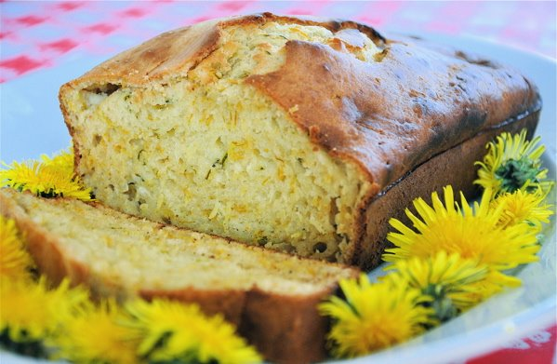
Ingredients
1 cup fresh dandelion petals (yellow part only)
7 cups flour
4.5 tbsp baking powder
1.5 tsp sugar
0.75 tsp slat
1/3 cup melted butter
1 egg
3.25 cups milk
Procedure
1. Harvest dandelion flowers, bring kids because they love this part. Then bring the petals home and dry them for 6-12 hours.
2. Mix flour, baking powder, salt, sugar
3. Mix dandelion petals into dry mix
4. Pour whisked egg, milk, and melted butter into dry mix
5. Mix all wet and dry ingredients just until mixed, do not over mix. The more you mix and kneed the harder your bread will be.
6. Preheat oven to 370
7. Lightly flour bread dough and place into a parchment covered pan/tray
8. Cook bread at 370 for 20 minutes, then turn and cook for another 20 minutes.
9. Check bread for doneness, if not fully cooked bake for another 10 minutes and check.
10. Allow bread to cool and serve with butter
“In a world full of roses, stand out like a dandelion in the middle of a plush green lawn!” ― June Stoyer
#wildfoodstastebetter #bestcoast #foragedfood #eatweeds #foodismedicine #myexistenceisresistance

