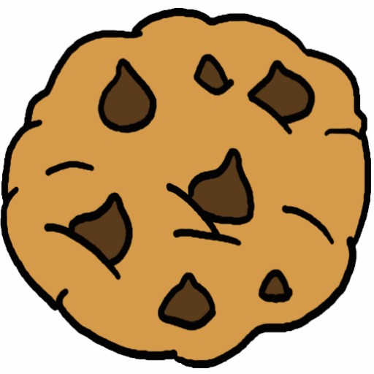 | Cookies

What Makes a Good Cookie?
Cookies come in all shapes and sizes ranging from small cookies served with tea to oversized cookies that are a dessert all by themselves
They come in a variety of ___________ and _____________. Some are sweet and crisp while others may be buttery with a soft chewy texture
Knowing how various ________________ and _________________ influence the characteristics of a cookie is important when trying to achieve a particular finished product.
Flavor
The flavor of cookies is primarily determined by the _______________________________ that make up the dough.
Proper proportion of ___________________ is also essential. Therefore, follow recipes
carefully and measure ingredients ___________________.
Texture
Choosing ___________________ flour can make cookies tough.
Crisper cookies have a larger proportion of ____________________.
Softer cookies contain more ______________________ and _____________________.
Chewy cookies get their texture from a higher amount of _________________ combined with
___________________, as well as more _________________.
Mixing and baking procedures also affect a cookie’s __________________.
Over-mixing the dough will develop too much ______________ creating a ___________ finished product.
Baking too long or at a temperature that is too high usually results in a ___________, hard
__________________.
Appearance
Shaping raw dough so the end product has a pleasing, attractive appearance is an important step for creating a quality cookie.
Ensuring that the shape is __________________ for all the cookies is key.
The portioning of the dough must also be consistent so the cookies are the same _________.
Baking at the proper temperature and for the proper length of time is essential for proper
_______________. This also ensures that the dough ______________ properly.
Remove cookies from the oven when the bottoms and edges turn _____________________.
Allow them to firm up slightly before removing them from the pan to avoid ______________
or ____________________ the cookies.

Cookie Problems
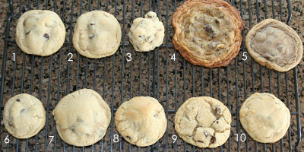

1.  2.  3.  4.  5. | 6.  7.  8.  9.  10.

Mixing Methods

How easy cookies are to make becomes clear when you learn the methods for mixing cookie dough.
There are two common methods for making cookie dough—the __________________
method and _____________________ method.
Both methods are done with an ________________ using the ______________ attachment.
One Stage Method
The one-stage method is the ___________________way to make cookie dough.
You place ____________ the ingredients into the bowl and mix.
Allow ______________________ at moderate speed to fully blend all the ingredients.
_____________________________can result in tough dough.

Creaming method
The first step in the creaming method is to mix the ____________ or _____________
with the sugar and spices until ___________________.
Next, _________________ and __________________ are added and mixed until incorporated.
Finally, the _______________ and ________________ agent are added and blended. Since the flour is added last, gluten is less likely to overdevelop using this method.
Forming Methods
Cookies can be classified by the method used to form the cookie.
Each technique creates a uniquely shaped cookie.
Drop Cookies
Drop cookies are the ________________ and most common method of forming cookies.
They are made by _________________ small amounts of dough onto a sheet pan.
A portion scoop is a good tool for creating __________________cookies.
During baking, the small mounds of dough _____________ into flat cookies.
When portioning drop cookies, allow enough space between the drops of dough to
allow the cookies to ______________during baking.
_________________ and _____________ cookies are often made using the drop method.
Rolled Cookies
To make rolled cookies, cookie dough is rolled out into a __________________ and a
________________is used to cut cookies into desired shape.
The cut cookies are transferred to a _________________ and baked.
The ___________________ cookie is a popular rolled cookie.

Spritz (Press) Cookies
Spritz cookies are made from ______________ cookie dough that is forced through a
______________________ to form shapes such as rosettes, shells and scrolls.
Some bakeshops use a special ___________________ to make these cookies. The dough is pressed through a specially shaped die to create specific shapes.
Sheet Cookies
Sheet cookies are made by ____________________ dough or batter onto a sheet pan.
The entire sheet pan is baked and later the sheet is cut into individual cookies.
______________________ are popular sheet cookies
This method of forming cookies has the advantage of _________________________.
Icebox Cookies
Icebox cookies are made by __________________cookie dough into a log, square,
triangle, or other shape while the dough is still _______________.
The shaped dough is wrapped in _______________ or ______________ and _____________________.
When fully _____________, the dough is firm and can be ______________into individual cookies.
Each slice of dough is laid out on a __________________ and baked to create individual cookies.
This technique makes it possible to create effect such as __________________or
______________________ by forming logs using different colors dough.
Bar Cookies
Bar cookies are made by __________________ cookie dough into approximate one- pound batches and forming it into a ________ about the length of a sheet pan.
The log is ______________ and _______________. Once the log has cooked and
while it is still warm, it is ________________into one-inch segments to form cookies.
These cookies are baked a _____________ time to create a hard texture.
__________________ are an example of popular bar cookies.

