The Chemistry of Quick Breads - Project

Your job is to create a presentation that goes through the science/chemistry of a recipe’s (one kind of quick bread) ingredients. Your power point (or other presentation) will give an overview of the role of each product in creating your quick bread. You must include a recipe and directions for making your quick bread recipe, identify which type pf quickbread your recipe falls into and identify the role/function of each ingredient in your recipe
You will be sharing your presentation with your peers in the class so choose a format that you are happy with whether it be a power point, prezi, slide show, video, poster, etc.

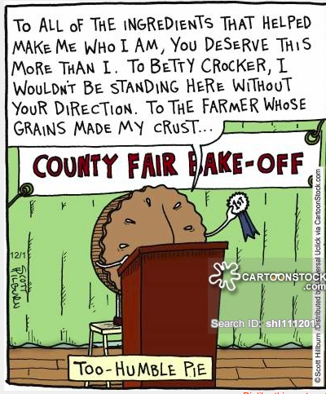 | Types of quickbreads:  - Biscuits  - Scones  - Muffins  - Fritters  - Crepes  - Pate a choux

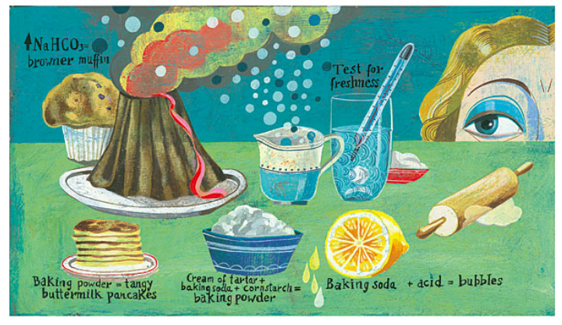
The recipe variations are endless you my do sweet or savory flavours.
Evaluation
Your job is to create a presentation that goes through the science/chemistry of a recipe’s (one kind of quick bread) ingredients. Your power point (or other presentation) will give an overview of the role of each product in creating your quick bread.

- Recipe and directions for your quick bread -------------------5 Marks

- Identify which type of quick bread your recipe falls into-------5 Marks

- Identify the role/function of each ingredient in your recipe---20 Marks

- Overall Presentation (visually appealing, neat presentation)-10 Marks

Total 40 Marks

Evaluation
Your job is to create a presentation that goes through the science/chemistry of a recipe’s (one kind of quick bread) ingredients. Your power point (or other presentation) will give an overview of the role of each product in creating your quick bread.

- Recipe and directions for your quick bread -------------------5 Marks

- Identify which type of quick bread your recipe falls into-------5 Marks

- Identify the role/function of each ingredient in your recipe---20 Marks

- Overall Presentation (visually appealing, neat presentation)-10 Marks

Total 40 Marks

