25 Bakeries Around the World You Have to See Before You Die
https://www.buzzfeed.com/candacelowry/bakeries-around-the-world-you-should-visit-before-you-die
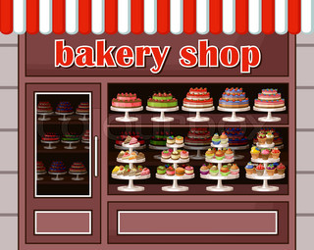

- Is there a bakery listed from Canada? If so what is its name and location?

- How many different Countries are represented in the list?

- Highlight 3 bakeries and tell me what makes them special.

