Baking Related Jobs

What is a Baker?
Breads, cakes, cookies, pastries, and pies.. oh my! These are just some of the delicious creations a baker can make.
A baker mixes and bakes ingredients according to specific recipes to make all sorts of baked goods. These baked goods are sold by grocers, wholesalers, restaurants, and institutional food services.

What does a Baker do?
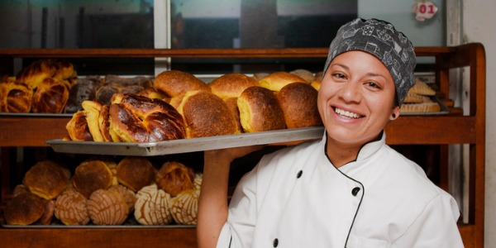
A baker will typically do the following:
- Check the quality of ingredients
- Prepare equipment for baking
- Measure and weigh flour and other ingredients
- Combine measured ingredients in mixers or blenders
- Knead, roll, cut, and shape dough
- Place dough in pans, molds, or on sheets
- Set oven temperatures
- Place and bake items in hot ovens or on grills
- Observe color and state of products being baked
- Apply glazes, icings, or other toppings using spatulas or brushes.
Types of bakers:
Commercial Bakers
Commercial bakers are commonly employed in manufacturing facilities that produce breads and pastries. In these manufacturing facilities, they use high-volume mixing machines, ovens, and other equipment to mass-produce standardized baked goods.
These types of bakers often operate large, automated machines, such as commercial mixers, ovens, and conveyors. They follow daily instructions for production schedules and recipes and also may develop new recipes.
Retail Bakers
Retail bakers work primarily in grocery stores and specialty shops, including bakeries. In these settings, they produce smaller quantities of baked goods for people to eat in the shop or for sale as specialty baked goods.
They may take orders from customers, prepare baked goods to order, and serve customers. Although the quantities prepared and sold in these stores are often small, they often come in a wide variety of flavours and sizes.
Some retail bakers own bakery shops or other types of businesses where they make and sell breads, pastries, pies, and other baked goods.
In addition to preparing the baked goods and overseeing the entire baking process, these workers are also responsible for hiring, training, and supervising their staff. They must also budget for supplies, set prices, and know how much to produce each day.

What is a Pastry Chef?
A pastry chef is someone who is schooled and skilled in the making of pastries, desserts, bread and other baked goods. Some pastry items may include cakes, cookies, cupcakes, pies, tortes and ice cream. Pastry chefs are employed in large hotels, bistros, restaurants, bakeries, and some cafés.
A pastry chef is typically found in a professional kitchen and is the station chef of the pastry department. As with other station chefs, the pastry chef may have other chefs or assistants within their department. Bakers may also be members of the pastry department in larger establishments. Some pastry chefs prefer to have their own small business, running a bakery or dessert shop.

What does a Pastry Chef do?
Pastry chefs create pies, candies, chocolates, cookies, cakes, ice cream, custards and bread. They not only create desserts but also order ingredients, keep inventory, deal with wholesalers, develop new recipes and provide input on menu-planning. The job demands abundant testing and sampling of new creations, which can be both rewarding and delicious. Nearly every restaurant, cafe, market and grocery store chain sells sweets and there is no doubt that people will always have a sweet tooth.
Some responsibilities of a Pastry Chef:
- Creating, testing and evaluating new pastry and dessert recipes
- Keeping a budget for the pastry department
- Buying fresh fruits and berries and ordering supplies from various vendors
- Supervising chefs in training in the pastry kitchen
- Discuss menu planning with the other chefs in the restaurant
- Keeping the kitchen organized

Explain what the differences between a baker and a pastry chef are:

Explore the BC government website to look at Baking relater jobs in BC. https://www.workbc.ca/Jobs-Careers/Find-Jobs/Jobs.aspx

B.C. has a variety of Baking related jobs. Go look at the baking related jobs listed in your area and choose 5 that would be of interest to you.

Job Title:
Salary:
Job Type:
Skills and Qualifications needed:

Job Title:
Salary:
Job Type:
Skills and Qualifications needed:

Job Title:
Salary:
Job Type:
Skills and Qualifications needed:

Job Title:
Salary:
Job Type:
Skills and Qualifications needed:

Job Title:
Salary:
Job Type:
Skills and Qualifications needed:

