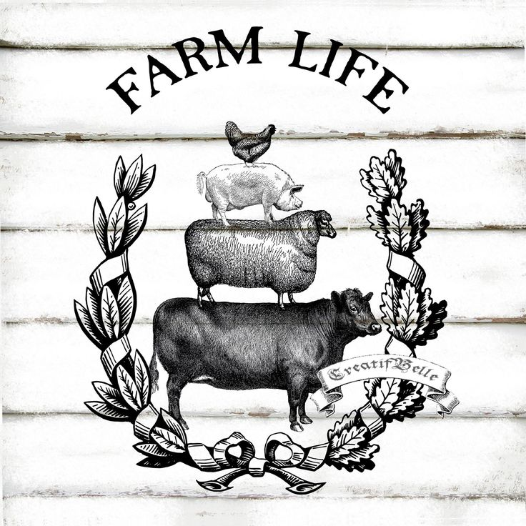 | BC Gov’t launches new resource to connect people with jobs in agriculture sector  Go read this Check News article about this new resource to help people connect with agriculture related jobs in BC.

- Do you believe that this resource would be valuable to people in BC? Why?

- The COVID-19 pandemic has shone a light on how important B.C.’s food supply and food supply workers are. As the food sectors prepare for 2020’s harvest season, employers need to fill labour jobs. Explain 3 ways you can get involved in supporting BC’s food chain.

- There are a variety of job opportunities in the B.C. farm, fish and food sectors, so how do you know which one is right for you? Choose 3 agriculture job types listed and describe them. Be sure to include a description of the job, the skills you need, is there any physical labour involved and what is the salary range

- B.C. has a variety of farm, fish and food regions. It’s home to more than 200 land based commodities and 100 marine based commodities. In fact, many of these jobs are right outside your backyard. Go look at the agriculture jobs listed in your area and choose 3 that would be of interest to you.

Job Title:
Salary:
Job Type:
Skills and Qualifications needed:

Job Title:
Salary:
Job Type:
Skills and Qualifications needed:

Job Title:
Salary:
Job Type:
Skills and Qualifications needed:

