All About Food - Exploring Canada’s Food System
Food Waste

Food waste in the home mainly comes from perishable food not being used before it expires. This may be because of confusion with labels and the meaning of a best before date. This date refers to the point at which a product is at its peak of freshness. Some foods are still safe to eat after the best before date; however, freshness, flavour and texture may change.

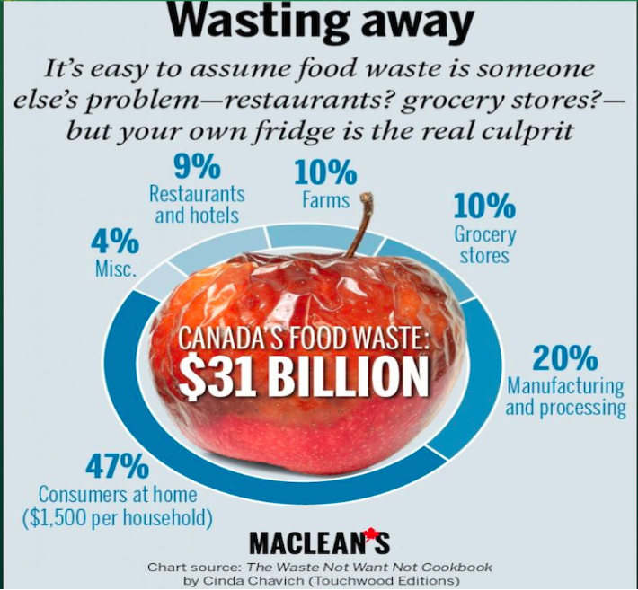

Watch Passionate Eye: Wasted: The Story of Food Waste
https://gem.cbc.ca/media/the-passionate-eye/episode-105/38e815a-010a50eca00

- What percentage of food waste comes from consumers at home? ______
- ______ of food produced is never eaten.
- Give a reason why there is food waste in the farms; in the restaurants; in the grocery stores.

- What is the “Upcycle Pyramid”?

- What percentage of grains are fed to livestock? ________
- Does the feed affect the taste and quality of the pork?

- How is eco feed different from corn or soy feed?

- What is the problem with planting the same commodity plant on the same piece of land over and over again?

- How is compost made?

- How long does a head of lettuce take to decompose in the landfill? _______________
- What can you do to reduce food waste at home?

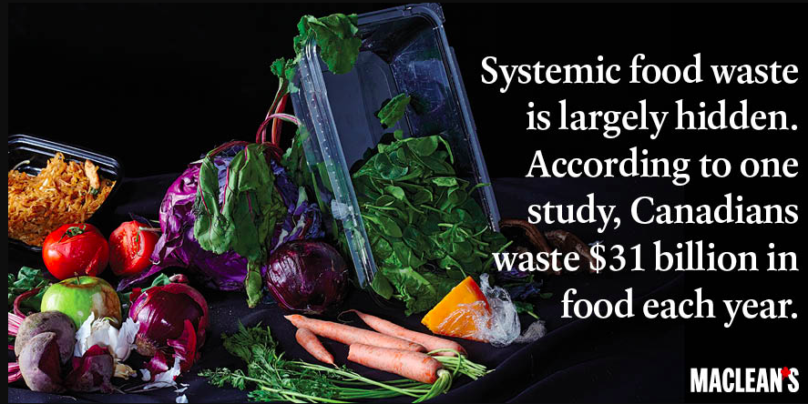
https://www.macleans.ca/wp-content/uploads/2015/05/social_sells_1821.jpg

Extension:
http://www.eatingwell.com/article/291645/farmers-cant-find-enough-workers-to-harvest-cropsand-fruits-and-vegetables-are-literally-rotting-in-fields/

