5 pts | 10 pts | 15 pts | 20 pts | 30 pts | 40 pts
Food Safety | Kitchen Equipment | Dinner Time! | Meal Plan | Food Factory Tours | Preparing Food
Take this Food Safety Quiz, utilizing the HINTS in the questions if you are not sure of the answers. Once completed, screenshot your score. Submit the screen shot to Mrs. Pinnell | Look at this article about  Kitchen Equipment  In your own kitchen attempt to find #’s  4, 7, 8, 12, and 16  Gather together and take a picture, insert here in this square...if you do not have any of these items, list them in this square. | Make/help make dinner for your family!  Complete this reflection when done | Create a Meal Plan from the supplies you have in your home  **You will not be making this food, just creating the plan for breakfast, lunch and dinner, using only supplies you already have in the house.  Complete this reflection when done | Choose one of the following factory tour videos to watch:  Bubble Gum , Cheez-It's Crackers, Chipotle Burritos  Answer the questions on the Food factory tour guide sheet: | Make a BREAKFAST meal using at least 7+ ingredients. Take at least 3 pictures:  Pic #1 - all your ingredients  Pic #2 - you making the food(s)  Pic #3 - the finished food(s) on a clean plate
5 pts | 10 pts | 15 pts | 20 pts | 30 pts | 40 pts
Game Night | Snack Hack | Organize! | Clean refrigerator | Healthy Breakfast | Preparing Food
Have a “game night” with snacks  Post a photo here of your fun!  Game Night Ideas | Create a “recipe” for your favorite snack on this recipe template  It must include the 7 parts of a recipe (all areas in grey).  And include a picture of your snack | Find a drawer, a shelf an area of your home that needs to be organized (get permission first) post a before and after photo here: | Clean & organize your refrigerator. Throw away old, expired foods (be sure to ask permission first!). Take a BEFORE & AFTER picture.  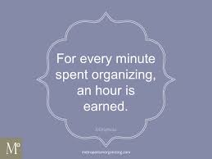 | Make a healthy breakfast that includes macronutrients. Take a picture and explain the macronutrients.  EXAMPLE: Wheat Toast (CARB), Scrambled Egg (PROTEIN), AVOCADO (FAT)  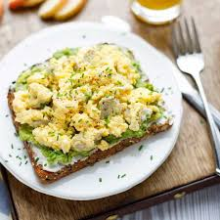 | Make a LUNCH meal using at least 10+ ingredients. Take at least 3 pictures:  Pic #1 - all your ingredients  Pic #2 - you making the food(s)  Pic #3 - the finished food(s) on a clean

