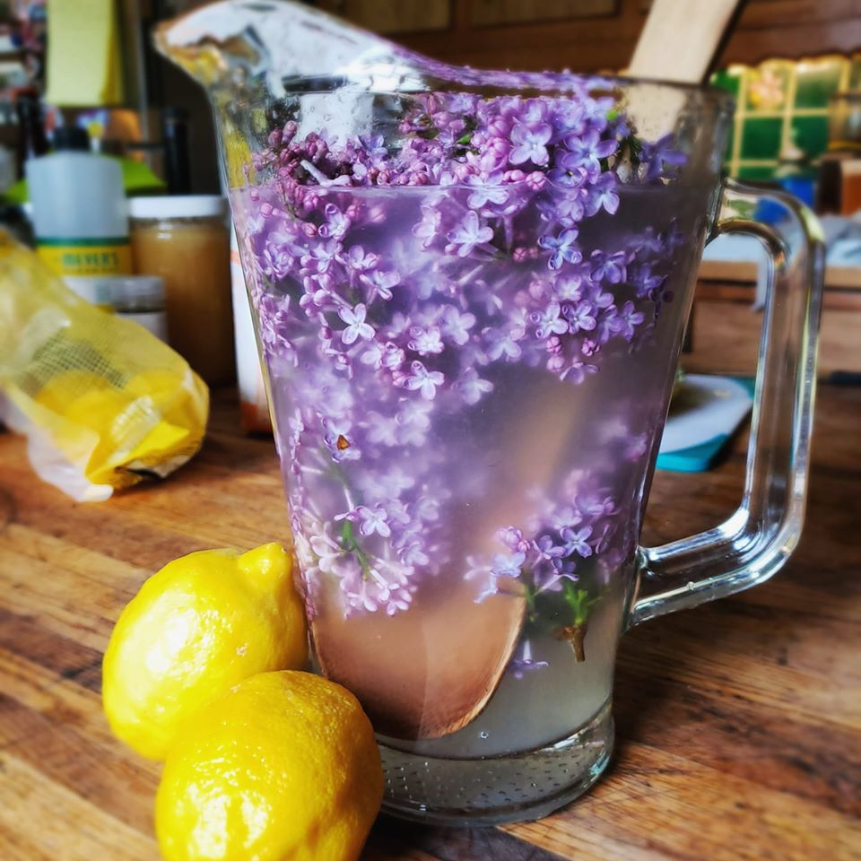 | Lilacs are so fragrant and give a delicately floral flavor to many foods and beverages such as this delicious lilac lemonade.  Lilac lemonade is very easy to make. If you have ever had lavender lemonade, this lemonade actually tastes very similar.  To make this easy lemonade, you will need about 2 cups of fresh lilac blossoms. Make sure to pick lilacs that have not been sprayed with any chemicals. Wash them to remove any insects and gently pull off the lilac blossoms to make two cups.

Lilac Lemonade Recipe
Ingredients:  - 2 cups lilac blossoms*  - 1 cup sugar or honey  - 16 cups water  - Juice of 4 lemons  This recipe makes approximately 1 gallon (16 cups) of lemonade. You can cut the recipe in half, and you can also adjust the recipe to suit your tastes if you would like to use less sugar or more lemon juice.  If you do not have fresh lemons, you can also use bottled lemon juice. One fresh lemon equals approximately 3 tablespoons of bottled lemon juice. | To really get the flavor of the lilac blossoms, you will need to boil the blossoms like you would to make tea. Place the lilac blossoms in a sauce pan and cover them with water. Bring the water to a boil.  Remove the pan from the heat and let it sit for about 20 minutes. The longer you let it sit, the stronger the lilac flavor will be. Strain the lilac blossoms out of the water with a fine mesh strainer.  Place the liquid in a 1 gallon container and add the sugar or honey, lemon juice, and remaining water. Stir. Refrigerate until ready to serve.

