Starches/Grains, Legumes/Beans, Nuts/Seeds
Insert images of items from your own house that may fall into these categories...you can use your phone, chromebook or just look up similar items online.  **Do not just copy stuff from infographic or online, i want to know what you are finding in your home pantry** | EXAMPLE  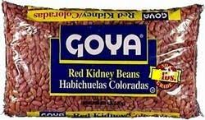
Canned and Shelf Staple Boxed Goods
EXAMPLE
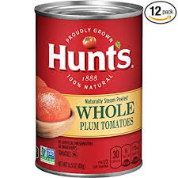
Oils, Vinegars, Condiments, Spices, Sweeteners
EXAMPLE
Vegetable Basics in Fridge (herbs, aromatics, citrus)
EXAMPLE
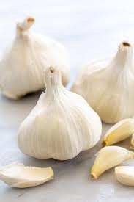
Dairy/Eggs Basics in Fridge (Dairy, yogurt, butter, eggs, cheese)
 | EXAMPLE
Frozen Foods (vegetables, proteins, meals)
EXAMPLE

