Starches/Grains, Legumes/Beans, Nuts/Seeds
Insert images of items from your own house that may fall into these categories...you can use your phone, computer, grocery store fliers, draw, or just look up similar items online.  **Do not just copy stuff from infographic or online, I want to know what you are finding in your home pantry** | EXAMPLE  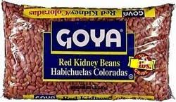
Canned and Shelf Staple Boxed Goods
EXAMPLE
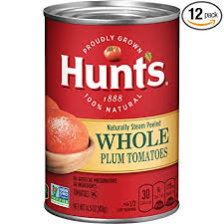
Oils, Vinegars, Condiments, Spices, Sweeteners
EXAMPLE
Vegetable Basics in Fridge (herbs, aromatics, citrus)
EXAMPLE

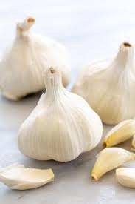
Dairy/Eggs Basics in Fridge (Dairy, yogurt, butter, eggs, cheese)
 | EXAMPLE
EXAMPLE

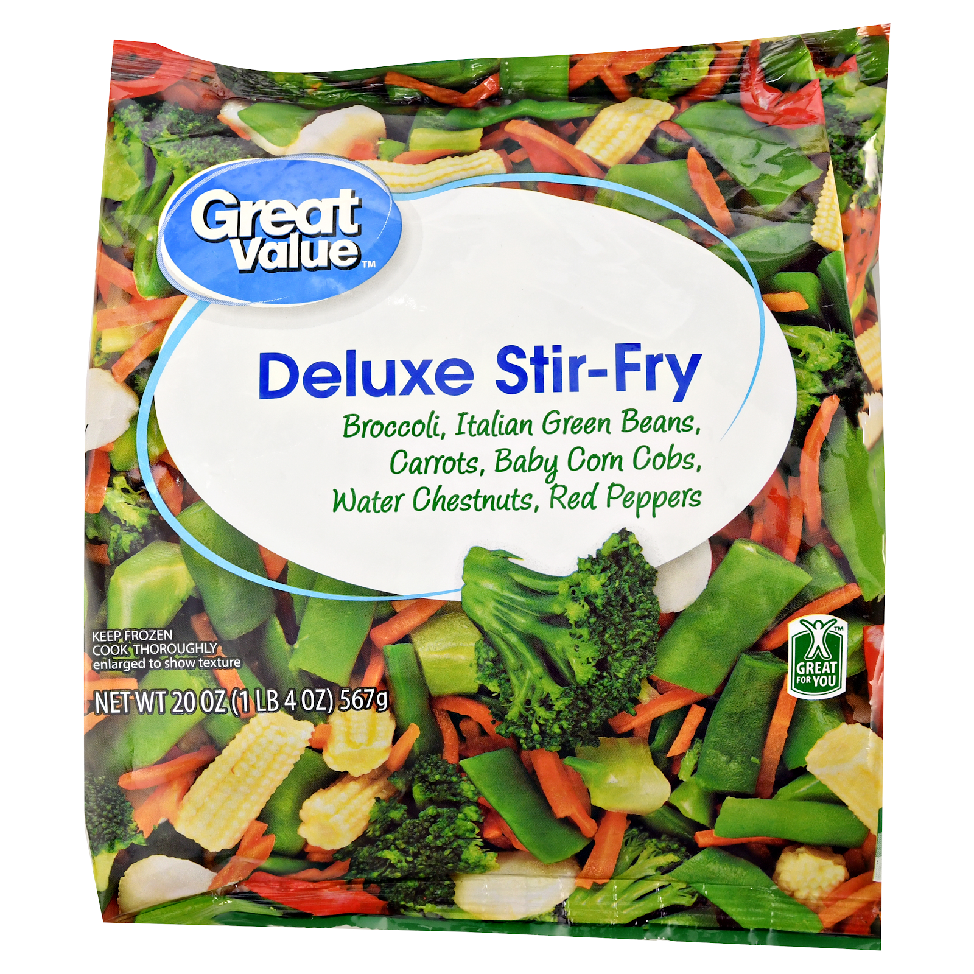
Baking Supplies
 | 