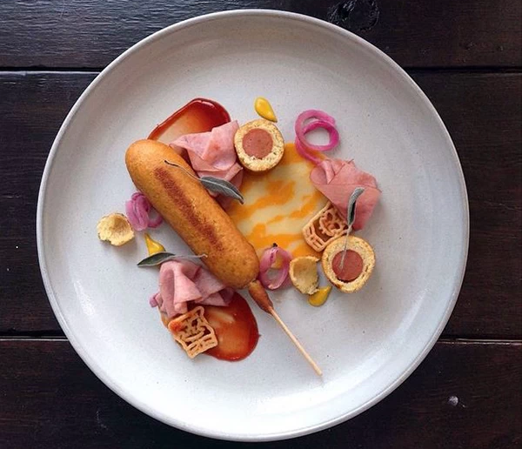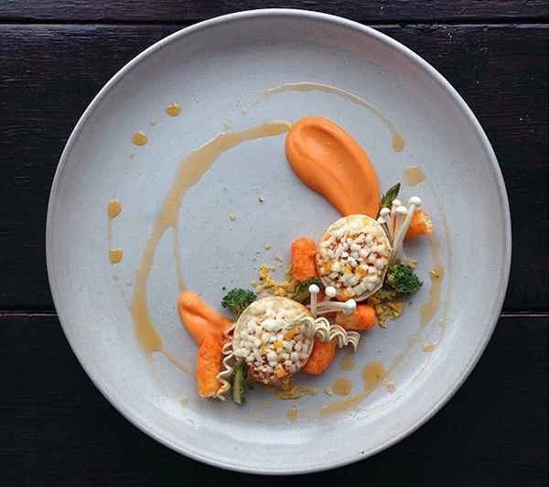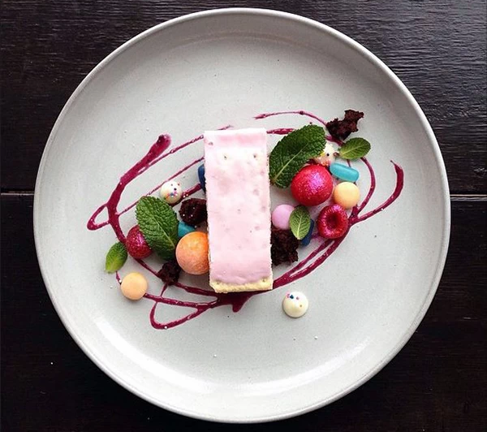
A
B
C

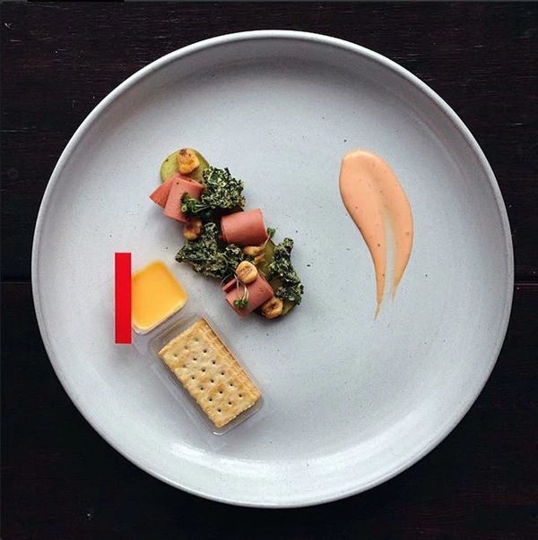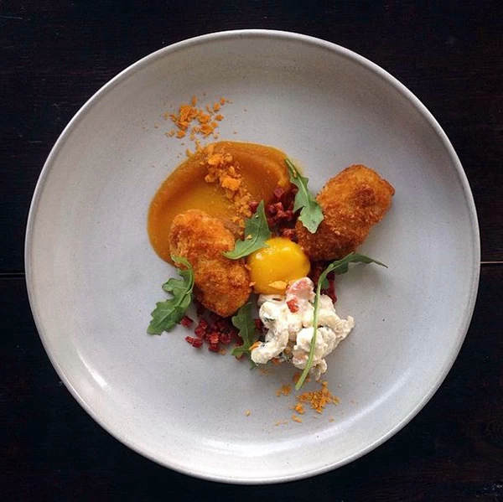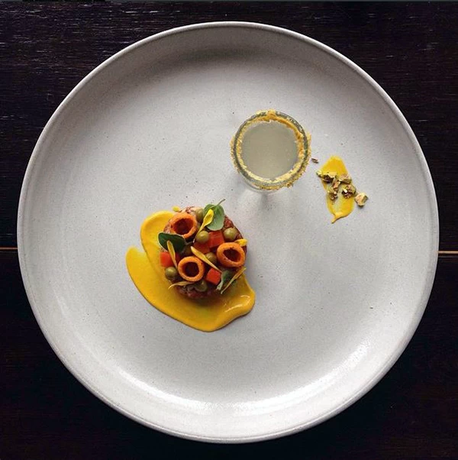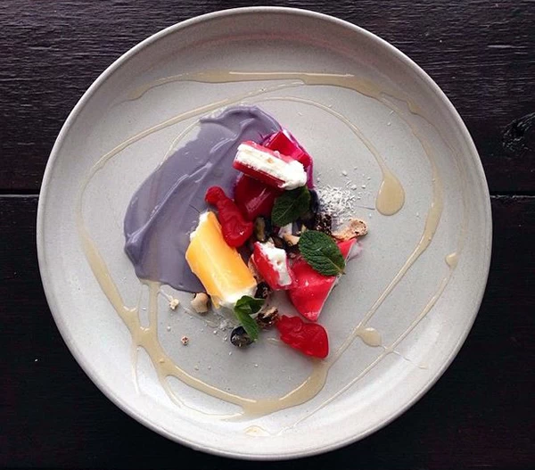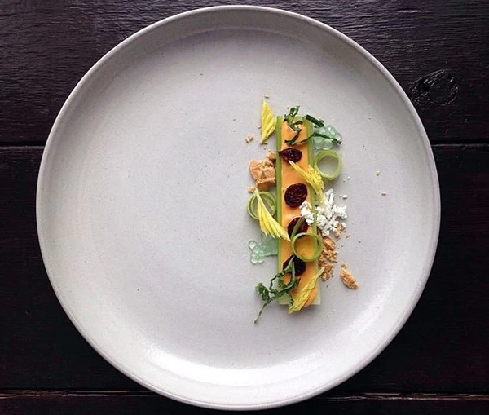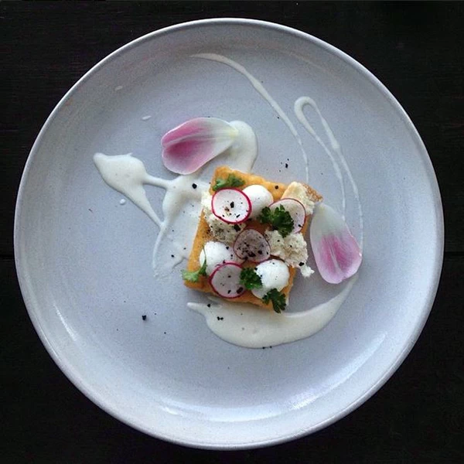
D
E
F
G
H
I
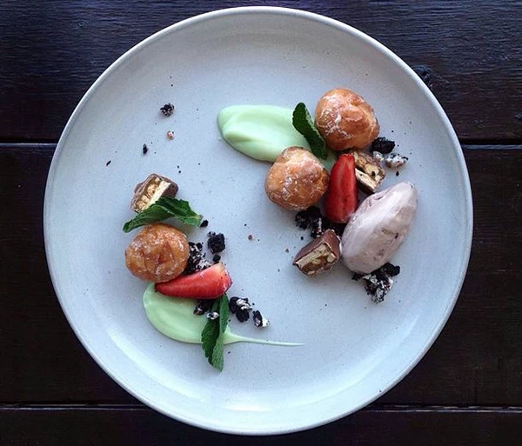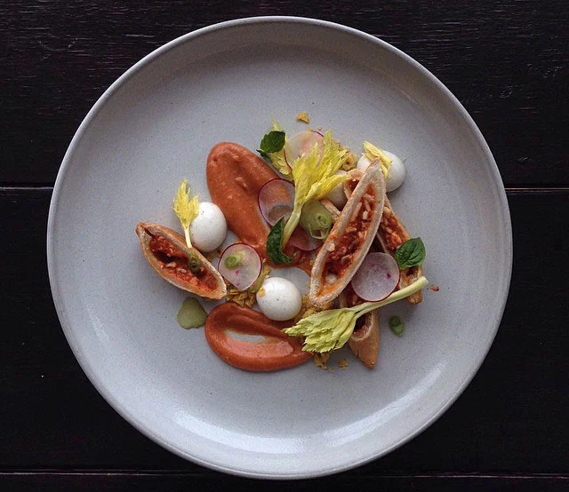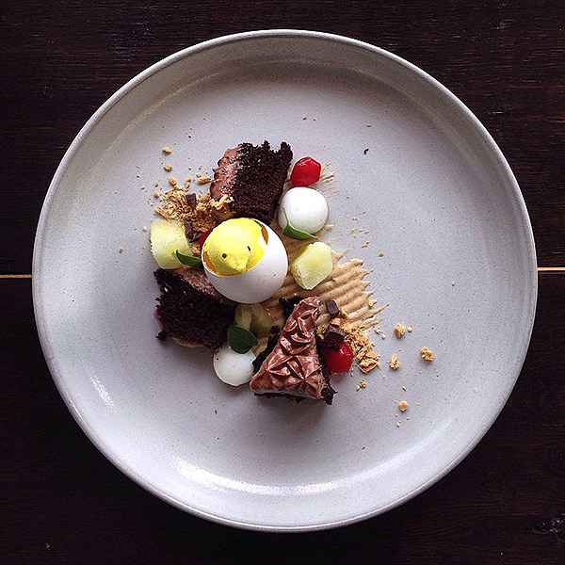
J
K
L

Perfectly Plated Dishes made of out Junk Food
Junk Food Name:____________________________________

- Bagel Bites, Cheetos & ranch with baby carrot purée ___________

- Celery stick topped with peanut butter and raisins and graham cracker crust ___________

- Cherry poptart with grape soda reduction, Mike and Ikes, Cry Baby candies and Mentos Fruit ___________
- Donut holes,cookie crumbles, snickers pieces, Moosetracks ice cream ___________

- Brownie pieces with a marshmallow peep in an egg shell and honey dew melon ___________

Breakfast sausage with frito circles, mustard, and a small glass of tap water with a yeast rim ___________

- Gummi dinosaurs and purple GO-GURT cream with chopped Creamsicle and Powerade gel ___________
- Corn dog with ham slices rolled up, mustard, ketchup, and spongebob shaped noodles ___________

- Filet-O-Fish with French fry puree, tartar sauce and radish slices ___________

- Cheese and crackers handi-snack with kale chips, ranch corn nuts, Bologna and a pickle, with thousand island dressing ___________
- Pepperoni hot pocket with marinara sauce and mozzarella spheres ___________

- Jalapeño poppers, diced pepperoni, goldfish crumbles, and an egg yolk __________

