Your job is to research cookies of various countries. You will choose a country from the list below and find four recipes for cookies from that country.

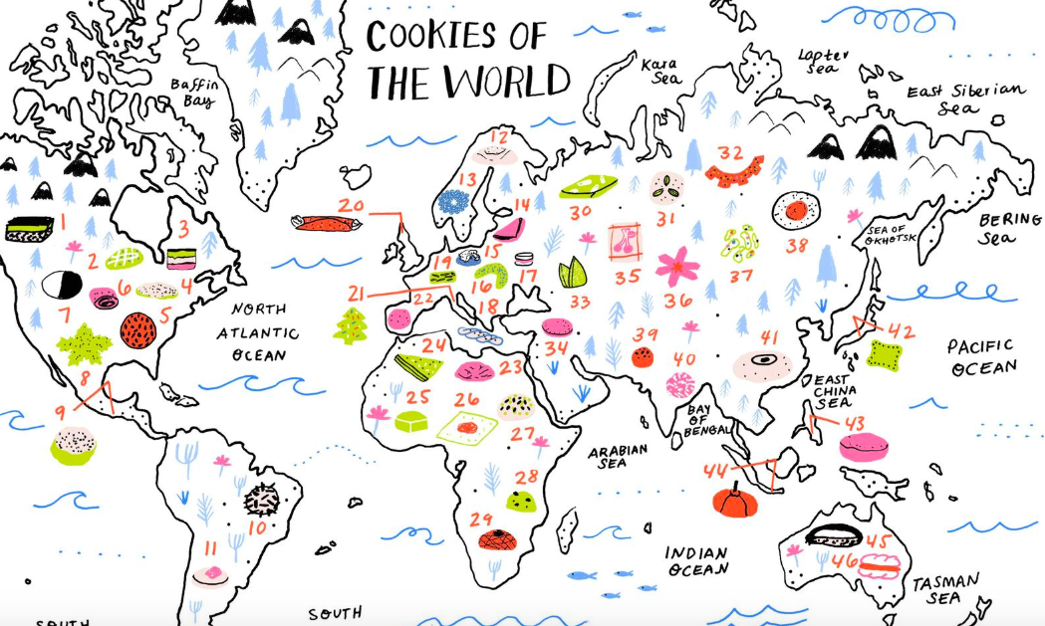

Identify the mixing method and the forming methods for each cookie.
You will display your findings on a poster, power point or some other presentation.

- There are two common methods for making cookie dough—the one-stage method and creaming method.
- There are a variety of forming methods for cookies: drop, rolled, spritz (pressed), sheet, icebox and bar cookies

List of countries for the project

- Mexico  - Brazil  - Peru  - Argentina  - Iran  - Russia  - India  - Philippines  - Singapore  - Austrailia | - Norway  - Sweden  - Poland  - Austria  - Greece  - France  - Spain  - UK  - Germany  - Italy  - Ukraine | - Serbia  - Japan  - China  - Malta  - Israel  - Alegria  - Nigeria  - Egypt  - Malawi  - South Africa

